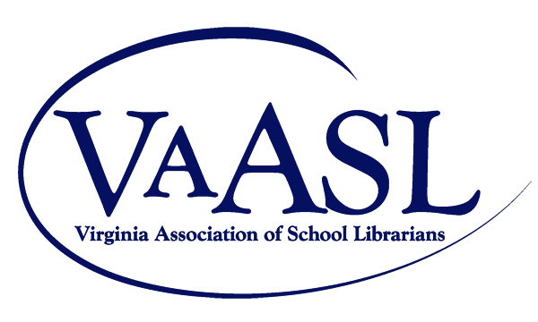

School Library Program of the Year Application

Online submission is required at vaasl.org/library-program-of-the-year-award. File submission includes uploading a completed copy of the application and supporting documents. Applicants must be current VAASL members.

Two letters of support must accompany this application.

Librarian Information
Name(s):

School DIvision:

School Name:

School Address:

Email:

Mission Statement

Evidence of Implementation of National School Library Standards

Ongoing Outreach

