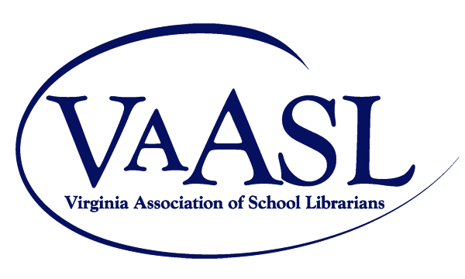

Ignite Project Application

Email submission to Patty Lambusta patrice4books@gmail.com . The submission includes a completed copy of the project application and supporting documents. Applicants must be current VAASL members.

Project Title:

Librarian Name:

School Name:

Designated Non-Profit Organization:

Partners

National School Library Standards

Project Overview

Service Learning Component

Learning Outcome

Works Cited

Student Evidence

Librarian Reflection

Additional Information

